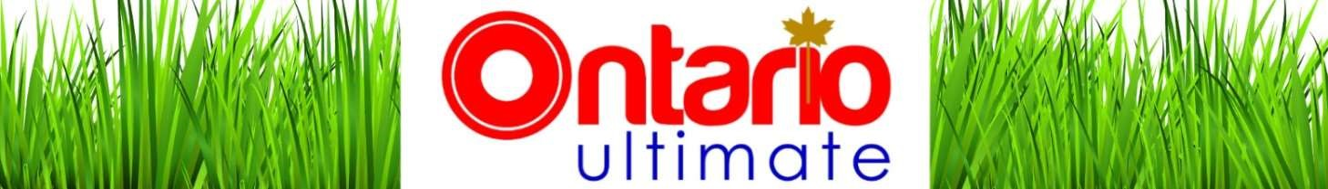

2018 Ultimate Season Membership
Release Waiver and Indemnity Form for Ontario Ultimate & GUPA
NOTE: This release form is a contract with legal consequences. Please read it carefully before accepting.
I want to participate in the 2018 ultimate season of Ontario Ultimate (OU) and GUPA. I understand and acknowledge that the sport of Ultimate may involve physical risk. I accept the responsibility for inspecting each area, course or field on which I play Ultimate in connection with Ontario Ultimate and GUPA and satisfying myself as to its safety. I certify that I am physically fit, have sufficiently prepared or trained for participation in this activity, and have not been advised to not participate by a qualified medical professional. I certify that there are no health-related reasons or problems which preclude my participation in this activity.
In consideration of the Ontario Ultimate and GUPA accepting me as a participant during the 2018 season, I, for myself, my heirs, executors, administrators, successors and assigns, here by release, waive and forever discharge Ontario Ultimate and GUPA its sanctioning body and sponsors and all their respective agents, servants, contractors, representatives, directors, elected and appointed officials, successors and assigns, of and from all claims, demands, damages, costs, expenses, actions and causes of action, whether in law or in equity, in respect of death, injury, loss or damage to my person or property how so ever caused, arising to or to arise by reason of my participation in the 2018 ultimate season, whether as a spectator, participant, competitor or otherwise, whether prior to, during, or subsequent to the 2018 season and not withstanding that same may have been contributed to or occasioned by the negligence of any of the aforesaid.
I further here by undertake to hold and save harmless and agree to indemnify all of the aforesaid from and against any and all liability incurred by any or all of them arising as a result of, or in any way connected with, my participation in the 2018 ultimate season.
By accepting this waiver, I acknowledge having read, understood and agreed to the above release, waiver and indemnity. I am aware that this is a release of liability and a contract and I sign it of my own free will. Lastly, I warrant that I am physically fit to participate in the 2018 ultimate season.
 | Membership Information
Name:
Current Address:
City: |  | Province: |  | Postal Code:
Email: |  |  | Phone:
Gender(M/F):
 | Signatures
□ Participant is 18 or older | Participant: |  |  |  | Date:
□ Participant is Under 18 | Parent/Guardian: |  |  |  | Date:

